Experiment: Car Price Prediction using Python
Aim
To implement a Car Price Prediction Model in Python using Linear Regression and predict the price of a car based on its features.
Procedure
- Import the required Python libraries.
- Create a car dataset containing features such as year, kilometers driven, and engine size.
- Separate the input features X and target variable y.
- Split the dataset into training and testing data.
- Create a Linear Regression model.
- Train the model using the training data.
- Predict car prices for the test data.
- Calculate the Mean Squared Error (MSE) and R² score.
- Provide the details of a new car and predict its price.
Python Program
import pandas as pd
from sklearn.model_selection import train_test_split
from sklearn.linear_model import LinearRegression
from sklearn.metrics import mean_squared_error, r2_score

# Create car dataset
data = {
"Year": [2015, 2016, 2017, 2018, 2019,
2020, 2021, 2017, 2018, 2020,
2016, 2019, 2021, 2015, 2018],
"Kilometers": [80000, 70000, 60000, 50000, 40000,
30000, 20000, 65000, 45000, 25000,
75000, 35000, 15000, 90000, 55000],

"Engine": [1200, 1200, 1500, 1500, 1600,
1600, 1800, 1500, 1600, 1800,
1200, 1600, 1800, 1200, 1500],

"Price": [350000, 400000, 500000, 600000, 700000,
800000, 1000000, 520000, 680000, 900000,
380000, 750000, 1050000, 300000, 620000]
}
# Create DataFrame
df = pd.DataFrame(data)

print("CAR PRICE DATASET")
print(df)

# Input features
X = df[["Year", "Kilometers", "Engine"]]

# Target variable
y = df["Price"]
# Split dataset
X_train, X_test, y_train, y_test = train_test_split(
X, y, test_size=0.3, random_state=42
)

# Create Linear Regression model
model = LinearRegression()

# Train model
model.fit(X_train, y_train)
# Predict test data
y_pred = model.predict(X_test)
print("\nActual Prices:")
print(y_test.values)
print("\nPredicted Prices:")
print(y_pred)
# Calculate performance
mse = mean_squared_error(y_test, y_pred)
r2 = r2_score(y_test, y_pred)

print("\nMean Squared Error:")
print(mse)

print("\nR2 Score:")
print(r2)
# Predict price of a new car
new_car = [[2022, 10000, 1800]]

predicted_price = model.predict(new_car)
print("\nNew Car Details:")
print("Year = 2022")
print("Kilometers = 10000")
print("Engine = 1800 cc")
print("\nPredicted Car Price:")
print(predicted_price[0])
Sample Output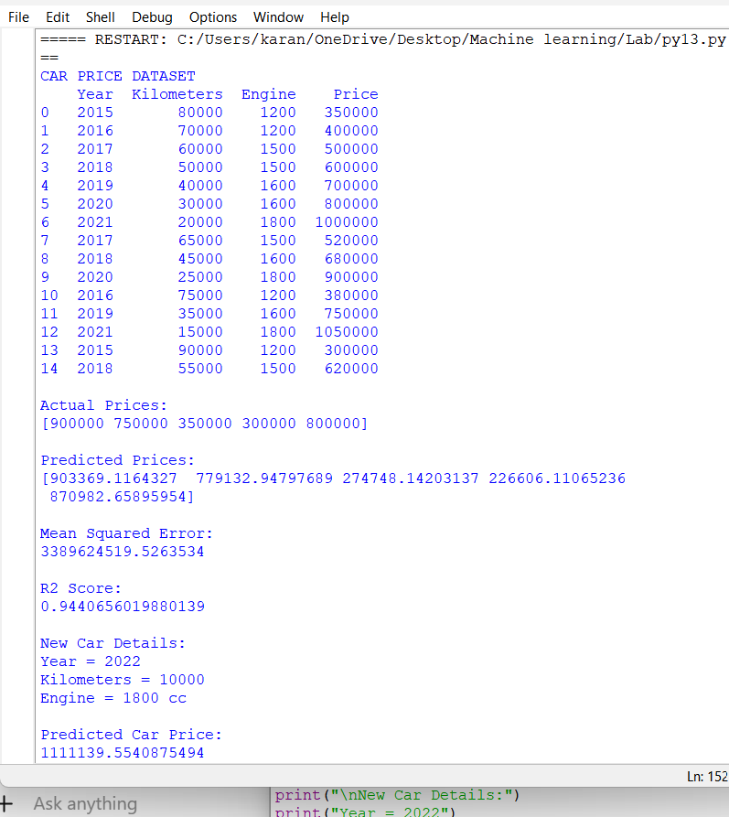
Result
The Car Price Prediction Model was successfully implemented using Linear Regression. The model was trained using car features such as year, kilometers driven, and engine capacity and was used to predict the price of a new car.

